Type the Title of your Paper Here

Author nameª, Co-Author nameª, Co-Author name^{b*}
ªAffiliation
Street, City, State, Zip-code, Country
^{b}Affiliation
Street, City, State, Zip-code, Country
* Corresponding author: C-author@xxxx.edu.cn

Introduction
Abstracts for the 5th ISUIS should follow this template and the instructions below. Abstract length is limited to two pages. Printed abstract booklets will be distributed at registration. Submission must be in *.docx format, with a maximum size of 3 MB. If you use Microsoft Word you may find it best to modify the docx version of this template file into your abstract. Please choose to embed all fonts. The filename should include the first author’s surname, the word abstract, and an abbreviated title. For this example, a good filename would be Surname-Abstract.docx. Before uploading your file, it would be helpful to view it on different computers to confirm the appearance of all fonts and graphics. The page size is B5(ISO) (17.6 × 25 cm), with 1 inch (2.54 cm) top and bottom margins and 1.25 inch (3.17 cm) justified side margins. The font is Times New Roman (except title for which use Arial), single-spaced, with font sizes as follows: title 13; authors 11, addresses 10; body text 10; and captions and footers 9. References should be in numerical order [1, 2] and should follow the conventions of Fire Safety Journal. Include the footer shown below on each page, but do NOT include page numbers.

Results and Discussion
Figures should be centered (Fig. 1). Make sure you use uniform lettering and sizing of your original figure. Aim to use the following fonts in your figures: Arial, Courier, Times New Roman, Symbol, or similar. Make sure that colored artwork is well represented when printed in black and white.
Equations should be edited by MathType software or Microsoft Equation 3.0. Please do not use the default equation editor of Microsoft Word. For equations, the size of all symbols MUST be set to 12 pt. Number your equations consecutively in the text and refer to them as Eq. (1), etc. However, if “Equation” is the first word in a sentence, spell it out. In principle, variables are to be presented in italics. Powers of e are often more conveniently denoted by exp. An equation style has been provided, which includes a right-aligned tab for the equation number and extra space after it. For example,
, (1)
where is mass (kg), is radius (m), and is temperature (K). Authors are also encouraged to use MathType software or Microsoft Equation 3.0 to edit the symbols of the equation in the text.
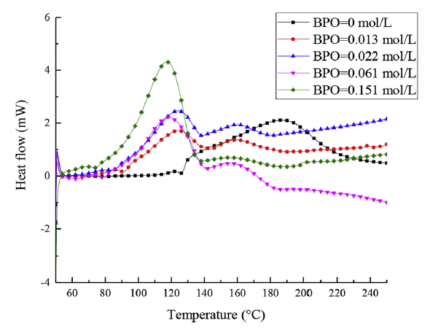
Fig. 1. Figure caption followed by a period.
Present simple formulae in line with normal text where possible and use the solidus (/) instead of a horizontal line for small fractional terms, e.g., .

References
Number the references (numbers in square brackets) in the list in the order in which they appear in the text. Each reference is single-spaced, with 0 pt before and 6 pt after the reference. All the words of the references should be 9 pt in size, and the notional words in references should be capitalized.
Examples:
Journal publication:
Van der Geer, J., Hanraads, J.A.J., Lupton, R.A., 2010. The art of writing a scientific article. J. Sci. Commun. 163, 51–59. https://doi.org/10.1016/j.Sc.2010.00372.
Book:
Strunk Jr., W., White, E.B., 2000. The Elements of Style, fourth ed. Longman, New York.
Chapter in an edited book:
Mettam, G.R., Adams, L.B., 2009. How to prepare an electronic version of your article, in: Jones, B.S., Smith , R.Z. (Eds.), Introduction to the Electronic Age. E-Publishing Inc., New York, pp. 281–304.
Website:
Cancer Research UK, 1975. Cancer statistics reports for the UK. http://www.cancerresearchuk.org/aboutcancer/statistics/cancerstatsreport/ (accessed 13 March 2003).
Dataset:
[dataset] Oguro, M., Imahiro, S., Saito, S., Nakashizuka, T., 2015. Mortality data for Japanese oak wilt disease and surrounding forest compositions. Mendeley Data, v1. https://doi.org/10.17632/xwj98nb39r.1.

